# Compass - Shipping Guidelines and Fees

Reminders

Cold Pack Shipping

Delivery Shipping Fees

Best Method

Urgent Next Day

2nd Business Day Delivery

Specified Carrier

Ship Consent Hold (Medicare D/EGWP Only)

Order Tracking

Questions and Answers

International Shipping

Exceptions

Related Documents

**Description** Provides guidelines to determine the company Mail Order delivery standards, tracking information, and costs associated with expedited shipping orders.

|  |
| --- |
| Reminders |

* Shipping fees are added to the cost of prescription orders. The Delivery Shipping Fees chart below provides shipping methods and their associated shipping fees and estimated shipping times; however, the order will still go through the additional standard processing times. For processing turnaround times, refer to [Order Shipping Turn Around Time (TAT) (062824)](https://thesource.cvshealth.com/nuxeo/thesource/#!/view?docid=31ee69db-e3d5-4717-b336-23ca51f1191e).
* For orders not received yet and not showing in the Mail Order History tab, refer to [Compass - Viewing, Adding, and Editing Member and Mail Alerts (054194)](https://thesource.cvshealth.com/nuxeo/thesource/#!/view?docid=36c941d2-25a6-4075-993d-f12deb31be18).
* The Mail Order pharmacy is open 365 days a year; however, orders may not be picked up from our facilities on Sundays or Federal Holidays.
* The last shipping time for Cold Packs is Thursday at 4pm at the filling pharmacy. Remaining Cold Packs will be shipped Monday morning.

Icon - Important Information Shipments are NOT normally set up for Saturday delivery, however this may occur on rare occasions.

**The PBM ships prescriptions to addresses in:**

* **United States (U.S.)**
* **U.S. Territories and Possessions** (including American Samoa, Guam, Northern Mariana Islands, Puerto Rico, US Virgin Islands, Wake Atoll) and U.S. Freely Associated States (including Marshall Islands, Micronesia, and Palau).

**Note** Cold Packs **can** be shipped to Puerto Rico. They **cannot** be shipped to US Territories and Possessions, including Guam, US Virgin Islands, and Wake Atoll.

* **Canada**

**Note:** Cold Pack prescriptions and prescriptions that are classified as controlled substances (CII, CIII, CIV, and CV) by DEA may NOT be shipped into Canada.

* **APO, FPO, or DPO** (APO: Army/Air Force Post Office; FPO: Fleet Post Office [Navy]; DPO: Diplomatic Post Office)

**Note:** Cold Pack prescription may NOT be shipped to an APO/FPO/DPO address.

**With the following exceptions:**

* **Canada** Create a Support Task. Refer to the “Scenario Guide” section of [Compass - Add, Edit, Delete Mailing Address (053255)](https://thesource.cvshealth.com/nuxeo/thesource/#!/view?docid=9cfb4422-7129-4bca-b1ea-f1d6fa964906).
* **Germany does not** allow prescription medications to be shipped to APO/FPO addresses within Germany.
* All **controlled substances** will be shipped by a traceable method. All C2s require the members’ signature. Schedule 3 to 5 controlled substances will not require a signature but will have confirmation from the shipping carrier that the package was delivered.
* The PBM should use the price of the line item on the Verify Order screen for each medication when completing the appropriate **international shipping forms**.
* When a member selects a P.O. Box address and requests **expedited shipping** (at member’s request or according to our internal criteria), the member is asked to provide a physical address for the order. If the member is unable to provide a physical address, create a Support Task, **Task Type** Refill Request-Offline Refills. Refer to [Compass - Support Task Types and Uses List (058147)](https://thesource.cvshealth.com/nuxeo/thesource/#!/view?docid=6753488f-3996-45d9-88ba-257575369a98). Include in the notes section of the task that the member is aware that the Cold Pack will be sent to a P.O. Box.

 Expedited and overnight shipping are not available in **Puerto Rico (PR)**. The United States Postal Service (USPS) is the only shipper used in PR.

Members with an **Oklahoma** mailing address can no longer use Mail Order. Run a Test Claim for alternatives, then educate members on their retail benefits or check the CIF for exceptions.

For Molina members, anywhere upgraded shipping can be added, once upgraded shipping is selected, the shipping cost will be $0. Do not proactively offer upgraded shipping.

**Notes**

* Refer to International Shipping for more information about shipping orders outside the U.S.
* Refer to Cold Pack Shipping for more information about Cold Pack orders.

**UPS and USPS are our exclusive package delivery services.** UPS is used for urgent next business day, 2nd business day, Express, and ground shipping. USPS services and SurePost (UPS) are used for standard shipping.

**SurePost** packages are picked up, sorted, and transited by the primary carrier (UPS), and then delivered to the local USPS who provides final delivery.

* UPS provides door-to-door tracking from [UPS.com](http://www.ups.com/WebTracking/track?loc=en_US), even after the package has been given to the USPS for final delivery. Both UPS shipping services provide USPS delivery confirmation, which is also available from UPS.com.

**Note:** There are a small percentage of SurePost packages that may be delivered by UPS and not handed off to USPS for final delivery.

**USPS EXP Parcel** The Wilkes Barre (WBP) and Chicago (CHI) automated Home Delivery/Mail Order pharmacies are now sorting some non-expedited packages less than 1 pound (based on zip code) for direct processing by the USPS. Once sorted, these packages will be picked up by the USPS and transported to their facility, where they will be processed and transported for final delivery to our patients the next day and second day. These packages will be entirely handled within the USPS network from end to end.

Top of the Document

|  |
| --- |
| Cold Pack Shipping |

When Shipping of Cold Chain Orders is Left as “Best Method”:

****For cold chain orders processed between Monday and Wednesday by 3 PM (local time of the dispensing pharmacy: WB in EST, CHI in Central), the package is expected to ship with a 2-day delivery service. If the order is processed after 3 PM on Wednesday, it will be shipped on Thursday with next-day ground or air delivery. Orders processed after 3 PM on Thursday will be shipped on Friday for next-day Saturday delivery, if UPS Saturday delivery is available in the recipient's zip code. If Saturday delivery is not available in the recipient’s zip code, the expectation should be a Monday pick up. In some instances, it may be picked up Saturday for a Monday delivery, but this is based on the volume of orders to be filled at the dispensing pharmacy. **Always set the expectation for the latest possible delivery date and validate that the member will have enough medication until that date.** Refer to [Member Low or Out of Medication (063003)](https://thesource.cvshealth.com/nuxeo/thesource/#!/view?docid=91f73b9d-e568-48dd-9ab4-88cb2654d4c9) as necessary. If the member requests to change the shipping method from a 2-day delivery period to next day, there will be a 23.00 charge. If the member requests a deviation from the standard cold chain delivery schedule, contact the senior team to explore available options for expediting.

Refer to the table below:

|  |  |  |  |
| --- | --- | --- | --- |
| **Day/Time of Week Order is Processed** | **Shipping Method** | **Expected Delivery** | **Notes** |
| Monday (before 3 PM) | 2-Day Delivery | Wednesday | 2-day delivery service |
| Monday (after 3 PM) | 2-Day Delivery | Thursday | 2-day delivery service |
| Tuesday (before 3 PM) | 2-Day Delivery | Thursday | 2-day delivery service |
| Tuesday (after 3 PM) | 2-Day Delivery | Friday | 2-day delivery service |
| Wednesday (before 3 PM) | 2-Day Delivery | Friday | 2-day delivery service |
| Wednesday (after 3 PM) | Next-Day Ground or Air | Friday | Next-day delivery for orders after 3 PM |
| Thursday (before 3 PM) | Next-Day Ground or Air | Friday | Next-day delivery |
| Thursday (after 3 PM) | Next-Day Ground or Air (Sat Delivery, if available) | Saturday (if available) or Monday | Next-day delivery if Sat delivery is available |
| Friday (before 3 PM) | Next-Day Ground or Air (Sat Delivery, if available) | Saturday (if available) or Monday | Next-day delivery if Sat delivery is available |
| Friday (after 3 PM) | Next-Day Ground or Air | Monday |  |
| Saturday | Processed Monday | Wednesday |  |
| Sunday | Processed Monday | Wednesday |  |

* **Shipping** For specific Cold Pack information, refer to [Cold Pack Packages (068152)](https://thesource.cvshealth.com/nuxeo/thesource/#!/view?docid=42b8115d-45ff-4172-9bc4-f3e0a26bde02). Our automated shipping process will check the National Weather Service forecast for your area for the time period that we expect your order to be delivered. Based on the temperature range during that time period, we will determine the best shipping method to use to protect insulin orders.
* Orders can be shipped either UPS Next, Express, OR 2nd Day shipping. For specific Cold Pack information, refer to [Cold Pack Packages (068152)](https://thesource.cvshealth.com/nuxeo/thesource/#!/view?docid=42b8115d-45ff-4172-9bc4-f3e0a26bde02).
* Compass will show an indicator for cold packed medications.

**Note:** Upgraded shipping functionality will be disabled to prevent expedited charges. Cold pack drugs are automatically expedited.

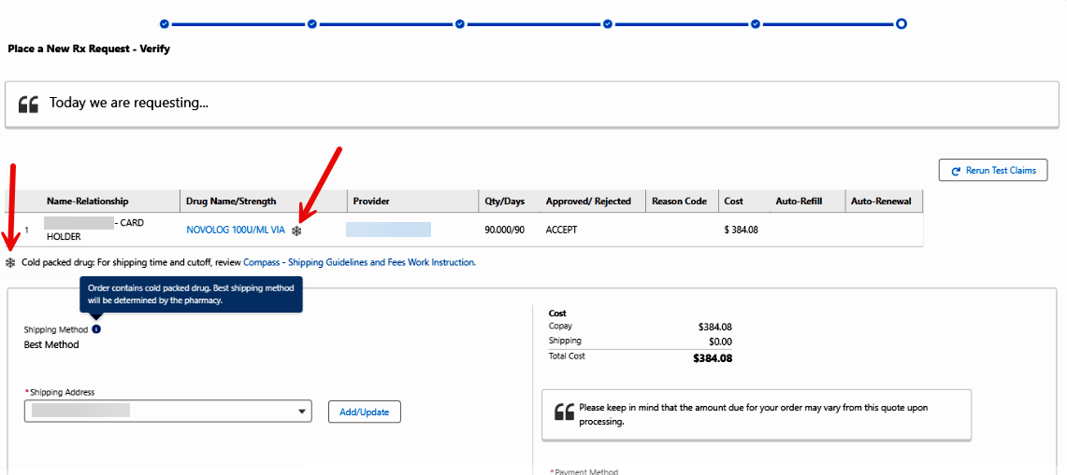

**Note:** When non–Cold Pack medications are ordered **with** a medication that requires a Cold Pack, the entire order will ship Urgent Next Business Day (the order will not be separated).

**Can I send a Cold Pack Order to a P.O. Box?**

When placing a **New Rx Request**, **Refill**, **Early Refill at Mail**, or **Transfer from Retail to Mail** the system will advise when a P.O. Box shipping address is selected for a drug that requires a Cold Pack. The warning will read “P.O. Box shipping address is not allowed due to this drug requiring a Cold Pack.”

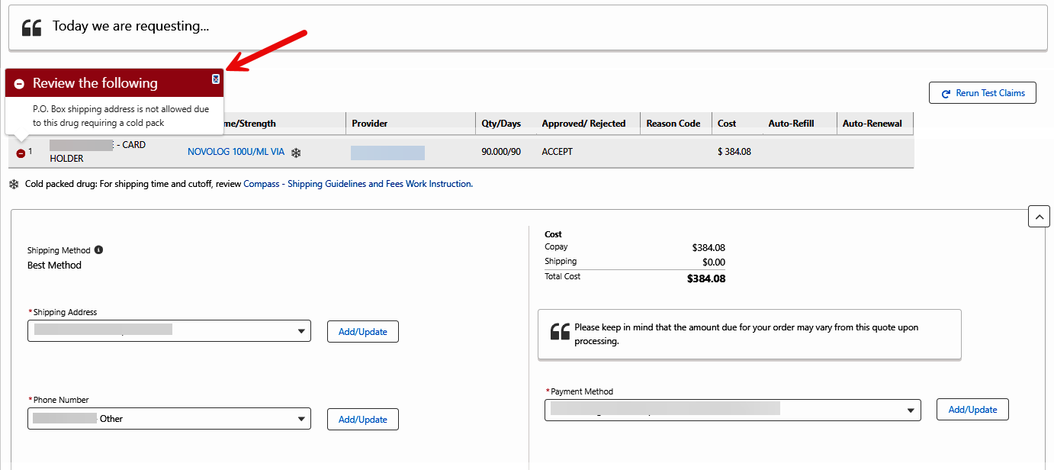

When you receive the above warning while submitting a **New Rx Request**, **Refill**, **Early Refill At Mail**, or **Transfer from Retail to Mail** resolve by following the appropriate steps below:

|  |  |  |
| --- | --- | --- |
| **If...** | **Then...** | |
| A physical address is available | * Click **Cancel**. * Click **Add/Update** and change the shipping address accordingly. * Click **Next** to complete the request. | |
| A physical address is not available | Click **Next** to continue. | |
| **If...** | **Then...** |
| Caller accepts risk | Click check box, then click **Place Order**. |
| Caller does NOT accept risk | Click **Cancel**. A physical address will need to be updated on the order before continuing. |
| Caller asks the risk of Shipping a Cold Pack to a P.O. Box | Advise the caller as follows  Please be aware, the Cold Pack will keep the medication at the required temperature for a limited time only. The medication may be compromised if it is not picked up in time. No reships will be allowed unless there are shipping delays/issues prior to delivery. Would you still like to continue with shipping the order to a P.O. Box? | |
| Caller indicates to NOT ask for a physical address again | Call the Senior Team for assistance.  The **Address Opt Out** box on the Mail Order Profile screen should only be selected by the Senior Team. | |

**Can I send a Cold Pack Order to an APO, FPO, DPO address?**

When placing a **New Rx Request** or **Refill** order with a Cold Pack, if the address listed is an APO, FPO, or DPO, you will receive a Warning Review Icon. The warning will read: “Cannot ship Cold Packed drugs to an APO, FPO, or DPO address.”

 To proceed with the order, the shipping address **must** be updated to an allowed address.

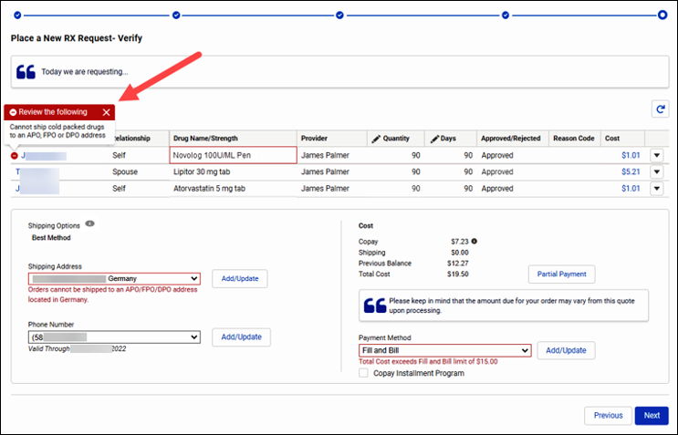

Top of the Document

|  |
| --- |
| Delivery Shipping Fees |

* Upgraded Shipping cannot be added to New Rx Requests until the Rx(s) are received in Compass from the provider’s office and have reached Processing status on the Mail Order History screen.
* Refill Orders, including Order Reships, require up two (2) business days processing before shipping.

 Delivery times are not guaranteed.

|  |  |  |
| --- | --- | --- |
| **Type of Shipping** | **Price** | **Expected Shipping Turnaround Times** |
| Cold Pack | No cost, and automatic for every prescription order that requires Cold Packaging. | When placing order, leave on the default “Best Method.” Shipment is updated to Next Day only AFTER order has processed.  **Note:** Cold Packs **can** be shipped to Puerto Rico. They **cannot** be shipped to US Territories and Possessions, including Guam, US Virgin Islands, and Wake Atoll. |
| Next Day | $23.00 | Delivered the next business day AFTER order has processed. |
| Second Day | $17.00 | Delivered two business days AFTER order has processed. |
| Standard (USPS and UPS Ground) | No cost | Any estimated delivery times are subject to mail delays outside of our control and do NOT include order processing times. For processing turnaround times, refer to [Order Shipping Turn Around Time (TAT) (062824)](https://thesource.cvshealth.com/nuxeo/thesource/#!/view?docid=31ee69db-e3d5-4717-b336-23ca51f1191e). |

**Notes**

* Shipping fees are added to the cost of the medications in the order.
* Any order with upgraded shipping will be automatically expedited once it reaches the pharmacy.
* Insulin orders that need a Cold Pack do not need upgraded shipping. Cold Pack orders are sent on the next day delivery at no additional cost to the members. The pharmacy will determine if an order needs to be shipped with a Cold Pack.

Refer to the table below:

|  |  |
| --- | --- |
| **Question** | **Answer** |
| **Will the previous version of the Mail Order pharmacy** **order form still be accepted at the pharmacies?** | Yes, the old forms will still be accepted. We will accept either the current form or the updated form. However, if someone selects 2nd day or next day delivery, we will charge the current fees, regardless of the form submitted. |
| **If someone sends in an old form, will this delay processing?** | There will be no delay in processing if an old form is used, however, it is best to use the most current form available. The current form is included with Mail Orders. It is best to shred old forms and keep the new forms received with recent orders. |

Top of the Document

|  |
| --- |
| Best Method |

Best method is known as **Standard Delivery** in which there are **NO** shipping charges to the member including both physical and P.O. Box addresses. Shipping methods below will be determined by filling facility as to which one will be the best method based on the medication in order. **NO** need to select either one when placing order unless member request faster delivery. See shipping options and cost below.

**Example:** If medication is insulin, pharmacy will send express mail at no charge to maintain the stability.

 Expedited and overnight shipping are not available in Puerto Rico (PR). USPS is the only shipper used in PR.

Those methods chosen are as follows and are all based on calendar days:

* 1st class
* Priority mail
* UPS ground (No deliveries to P.O. boxes)
* SurePost
* UPS next day air (Can be used for Cold Pack)
* UPS Next Day air saver (Can be used for Cold Pack)
* UPS 2 Day Air (Can be used for Cold Pack)
* USPS Express (Can be used for Cold Pack)

**Note:** Do not provide an exact or estimated delivery date. If there is a tracking number assigned to order, provide tracking number with the delivery carrier. As arrival dates can change.

**Example:** Weather conditions.

Top of the Document

|  |
| --- |
| Urgent Next Day |

Urgent Next Business Day Deliveries are available to the member upon request for the shipping charge of $23.00.

**Note:** Shipping fees are in addition to the cost of the medications in the order.

The shipping methods include the following for street addresses only. This excludes P.O. Boxes:

* UPS Next Day Saver

**To upgrade shipping for an open order:**

* Access the **Order Status** screen for the order in question and select the type of shipping from the Shipping Method drop-down box. Click the **Update** button to submit a change in shipping method.

**Note:** The order must be prior to Label Print status. Orders in Label Print should not be upgraded. Refer to [Expediting Mail Order Processing Time and/or Upgrading Order Shipping (118121)](https://thesource.cvshealth.com/nuxeo/thesource/" \l "!/view?docid=97e4d878-f5fe-4901-8e76-4439f248ed76).

**Urgent Next Day business Delivery for Post Office Box Addresses:**

Express Mail is the shipping method used for expedited orders going to a P.O. Box address.

**Reminders:**

* UPS will not deliver any orders to P.O. boxes.
* Expedited Shipping only applies to Shipping and not the processing of the order, continue to quote up to two business days processing for refills and up to five (5) business days for new prescriptions.
* Weekends and Government (Federal) holidays are not included.
* Saturday delivery is **NOT** available unless chosen at the Metering Station.
* It is not needed or necessary to select upgraded shipping for Cold Packed medications, as this is upgraded to Urgent Next Day at no additional member cost.
* UPS is our preferred shipping vendor. If the member requests FedEx, contact Participant Services at **1-800-378-6043.** If after hours, contact Senior Team for an email and send an email with the member details (Member ID, Order Number, callback number, and details of the matter). Participant Services will make an outbound call to the member to inform them that UPS is our shipping vendor and ask if we can ship the package via UPS. Refer to [Compass - Create a Support Task (050031)](https://thesource.cvshealth.com/nuxeo/thesource/#!/view?docid=64f18e5a-4d56-4175-ba8e-e7d094e501d6).

**Notes:**

* FedEx delivery should only be offered as a last resort in escalated cases.
* Saturday delivery is reserved for escalation issues and unless it is a Cold Pack then it ships on Friday.

Top of the Document

|  |
| --- |
| 2nd Business Day Delivery |

The member has the option to request a 2-day delivery for which they will be charged $17.00.

**Note:** Shipping fees are in addition to the cost of the medications in the order.

Ship methods include:

* UPS 2nd day (No deliveries to P.O. boxes)
* 2nd day shipping applies to the shipping and NOT the processing of the order. Continue to quote 1-2 business days processing for refills and 4-5 business days for new prescriptions

**To upgrade shipping for an open order:**

* Access the **Order Status** screen for the order in question and select the type of shipping from the Shipping Method drop-down box. Click the **Update** button to submit a change in shipping method.

**Note:** The order must be prior to Label Print status. Refer to [Expediting Mail Order Processing Time and/or Upgrading Order Shipping (118121)](https://thesource.cvshealth.com/nuxeo/thesource/#!/view?docid=97e4d878-f5fe-4901-8e76-4439f248ed76).

Top of the Document

|  |
| --- |
| Specified Carrier |

A specified carrier **ONLY** determines the preferred carrier. Requests for upgraded shipping will still incur charges as appropriate.

 Members must be informed that request does **not** guarantee all orders will be shipped via the specified carrier; however, the pharmacy will do their best to accommodate.

The member can request to have all orders delivered by one of two carriers: USPS or UPS. Perform the steps below to set the members’ preferred shipping method:

|  |  |
| --- | --- |
| **Step** | **Action** |
| **1** | From the Member Snapshot Landing Page, click the **Mail Order Profile** tab.    **Result:** Mail Order Preferences will display. |
| **2** | In the **Preferred Shipping Method** field, select from the following options:   * **First Class Mail All** orders will be shipped USPS.   **Note** This selection does NOT mean all orders will be shipped via 1st class mail. The filling facility will determine if 1st class is the best method once the package is weighed.   * **UPS** All orders will be shipped via UPS. * **Best Method** Shipping methods below will be determined by filling facility as to which one will be the best method based on the medication in order. For more information, refer to the Best Method section of this document. |
| **3** | Click **Save**. |

Top of the Document

|  |
| --- |
| Ship Consent Hold (Medicare D/EGWP Only) |

 By law (per CMS - Centers for Medicare & Medicaid Services), we are required to gain consent from Medicare and select EGWP (Employer Group Waiver Plans) members prior to refilling their prescriptions.

**Notes:**

* When ship consent is required, beneficiaries will receive ship consent alerts.
* Consent attestation is only required for orders generated by the Automatic Refill program for beneficiaries that are filling their prescription under a new Med D plan for the first time and do not have any history with mail order, or the beneficiary has requested consent attestation for their prescription refills.

Perform the following steps to turn on/off a member’s Ship Consent Hold (SCH):

|  |  |  |
| --- | --- | --- |
| **Step** | **Action** | |
| **1** | From the Member Snapshot Landing Page, click the **Mail Order Profile** tab.  **Result:** Mail Order Preferences will display.    **Note:** When a client is not set up for SCH, the **Ship Consent Hold** checkbox is disabled. | |
| **2** | Follow the steps below to either add or remove consent: | |
| **If…** | **Then…** |
| Adding Consent  **Only** for beneficiaries who:   * Prefer to consent to every Mail order * Are moving to an LTC facility and they do not need their mail order    CCRs are NOT to enter a **Mail Order Alert** to account when beneficiary requests to consent to every Mail Order. | * Inform the beneficiary that consent is required for every Mail Order Rx.   **Note:** Opting into SCH affects ALL medications on the account.   * Click the checkbox to add required consent.     **Result:** Are **you sure** modal will display.   * Select the appropriate choice from the **Ship Consent Hold Reason** drop-down menu. The Agent can select from the following different reasons: * Member Preference * Client Required * Hospice * Long Term Care * Maximum Returns      * Click the **Yes**button to continue or click **Cancel** to exit. * Proceed to the next Step.   If the **Ship Consent Hold Reason** drop-down menu does not populate and you are unable to complete this step, proceed as follows:   * Educate the caller that the request will be made to update consent required. * Warm Transfer to the Senior Resolution Team **Escalation** Line to complete this process. Advise the Senior rep as follows:   Hello, my name is < > and I am calling from < >. I need to have the Ship Consent turned back on for this account. I have educated the beneficiary on the process, and they have been made aware that the consent is being placed back on the account and will be needed for future orders.  **Note: SRT** **Escalation** will update consent. Continue the call as normal. |
| Removing Consent  **Only** for beneficiaries who:   * Have self-opted in * Have filled at least one/any RX using CVS/Caremark Mail Service Pharmacy under their current plan in the past twelve (12) months * Have contacted us to advise they are no longer in an LTC facility | When a client is set up for SCH, the Agent can uncheck a Member’s **Ship Consent Hold** checkbox to “turn off” SCH.   * Click the checkbox to remove required consent.     **Result:** Are **you sure** modal will display.     * Click the**Yes** button to continue or click **Cancel** to exit. * Proceed to the next Step. |
| **3** | Verify that the change was successful:   * When the change is successful, the member is taken to the **Maintain Patient Profile** page and the following message displays “Ship Consent Hold Status was successfully changed.”      * When the change is not successful due to system error, the member is taken to the **Maintain Patient Profile** page and the following message displays “An error has occurred. Please contact your System Administrator.” (The **Ship Consent Hold** checkbox reflects the Ship Consent Hold prior to the status change.) | |

Top of the Document

|  |
| --- |
| Order Tracking |

**My USPS** Members may register for a free My USPS account to automatically see all of their inbound USPS packages without having to enter any tracking numbers. The member can also use My USPS to schedule delivery alerts, request redelivery, set mail holds, and more.

**UPS My Choice** This service, PROVIDED BY UPS, may be of interest to the member if they have concerns about signature required or not being home when the package arrives.

* UPS My Choice provides delivery alerts and options to reschedule the delivery date or reroute to another address.
* It applies to all packages carried by UPS, not just those sent by the PBM.
* Fees apply to some options.
* Members can sign up at <http://www.ups.com/mychoice>.

**Note:** A signature will be required for all medications shipped with Cold Packs when the destination temperature is below 33 degrees.

Prior to providing tracking information to the member, verify the order’s time of completion by clicking on the Mail Order History Landing page.

|  |  |  |
| --- | --- | --- |
| **If the order…** | **Then…** | |
| Is completed after 5 pm local time | It may not be picked up by the home delivery vendor until the following business day. | |
| Does NOT have a “**Blue**” link displayed | 1. Copy the tracking number from the Mail Order History Landing page. 2. Open a new Google Chrome browser window and navigate to <https://www.usps.com/>. 3. Paste the tracking number into the Tracking box at the top left of the webpage. 4. Click the **Track** button. 5. View the tracking information for the order and advise the member accordingly. | |
| Has a “**Blue**” link displayed | It can be tracked via the vendor. Click the link to determine which shipping vendor was used. | |
| **If shipped by…** | **Then…** |
| UPS, SurePost, FedEx, Express Mail (USPS) | 1. Provide tracking information to the member (current progress, expected delivery date, etc.). 2. Offer to provide the member with the tracking number so that they can keep track of delivery progress on their own.   The member can contact the shipping carrier or visit their website for tracking updates.  **UPS & SurePost**  1.800.PickUPS (800.742.5877)  [www.UPS.com](http://www.UPS.com)  **United States Postal Service (USPS)**  1.800.ASKUSPS (800.275.8777)  [www.usps.com](http://www.usps.com) |

Top of the Document

|  |
| --- |
| Questions and Answers |

Refer to the table below:

|  |  |  |
| --- | --- | --- |
| **#** | **Question** | **Answer** |
| **1** | How do you know what the temperature will be in my area when you ship my insulin? | Our automated shipping process will check the National Weather Service forecast for your area for the period that we expect your order to be delivered. Based on the temperature range during that time period, we will determine the best shipping method to use to protect your insulin.  **Note:** The dispensing pharmacy will also follow manufacturer guidelines on heat sensitive medications. |
| **2** | Why didn’t you call me first before you shipped my insulin? | The PBM can notify you when your order is shipped or when we have other important information about your Mail Order prescriptions. You can choose to be notified by e-mail, telephone, or text message. I can sign you up right now or you can sign up at the Member Web Portal.  **Note:** If additional information about insulin stability/safety is required, please transfer the caller to a Clinical Care pharmacist. |
| **3** | Will my insulin sit in a hot delivery truck for days? | The PBM controls this situation from happening by packing and shipping your insulin to you in a manner that is best suited to protect your medication, based on the current delivery schedule and temperature. |
| **4** | My insulin sat in a hot delivery truck. Is it still good? | The PBM packs and ships your insulin to you in a manner that is best suited to protect your medication, based on the current delivery schedule and temperature. If you have additional questions, let me transfer you to a Clinical Care pharmacist for assistance. |
| **5** | My insulin did not feel cool when I opened the package. | Your insulin vials may not feel cool to the touch when you receive your shipment. Insulin vials may be stored at room temperature for a limited time.  **Note:** If additional information about insulin stability/safety is required, transfer the caller to a Clinical Care pharmacist. |
| **6** | What about insulin pens, cartridges, and inlets? Are they are shipped with cold gel packs? | The PBM packs and ships your insulin to you in a manner that is best suited to protect your medication, based on the current delivery schedule and temperature.  **Note:** If additional information about insulin stability/safety is required, transfer the caller to a Clinical Care pharmacist. |
| **7** | The cold gel pack was not frozen when I received my insulin shipment. Is that normal? | Cold gel packs are not designed to remain frozen solid. They will become soft during shipping but will continue to protect your insulin.  **Note:** If additional information about insulin stability/safety is required, transfer the caller to a Clinical Care pharmacist. |
| **8** | I am concerned about my insulin. Is it safe to use? How can I tell? | Since this is a question about insulin safety and stability, let me transfer you so that you can talk with a Clinical Care pharmacist. |
| **9** | Can I request signature required for my prescription orders? | Yes, for which medication are you requesting signature requirement?  **Note****:** Each carrier has different requirements for signature confirmation. Check the carrier website if the member has questions regarding the requirements.  **Note:** Refer to the Requests for Signature Required or NO Signature Required section of [Compass - Dispensing Special Instructions (053542)](https://thesource.cvshealth.com/nuxeo/thesource/#!/view?docid=7e45fb8b-f0e4-437e-9238-c8e37a504de8). |
| **10** | Can an RX be mailed as General Delivery?  How do I address a mail piece sent to General Delivery? | General Delivery is a mail service for those without a permanent address, often used as a temporary mailing address.  MEMBERS’ NAME  GENERAL DELIVERY  CITY, STATE ZIP |
| **11** | I would like my order left a specific location at my home like my back porch, Garage Door, front office apartment? | At this time, our systems do not let us specify a delivery location at the provided address. If you would like to specify a location such as your front porch, side porch, garage, etc. We recommend contacting your delivery service (USPS, UPS, etc) to set up a specific drop off location at your provided address. |

Top of the Document

|  |
| --- |
| International Shipping |

The PBM ships prescriptions internationally according to the following rules and restrictions:

**U.S. Territories:**

* The PBM ships prescriptions to U.S. Territories with no restrictions on Controlled Substances.
* **Cold Packs** cannot be shipped to some U.S. Territories and possessions (including American Samoa, Guam, Northern Mariana Islands, US Virgin Islands, Wake Atoll) and US Freely Associated States (including Marshall Islands, Micronesia, and Palau).

**Note:** Cold Packs can be shipped to Puerto Rico.

 Cold Packs can be shipped to military addresses if the address is listed on the FHP Exclusion list.

**APO, FPO or DPO Boxes:**

* The PBM ships prescriptions to APO, FPO or DPO Boxes except for Germany. Controlled substances are shipped, but not prescriptions requiring Cold Packs.

**Germany**

* The **German** government is NO longer allowing prescription medications to be shipped to APO/FPO/DPO addresses in Germany. Address must be updated to complete the order. For a list of German Zip Codes blocked from APO/FPO/DPO Shipments refer to [Participant Services APO and FPO German Zip Codes (072122)](https://thesource.cvshealth.com/nuxeo/thesource/#!/view?docid=e6df9c36-51fa-4593-b9ad-2bb4fc839552).

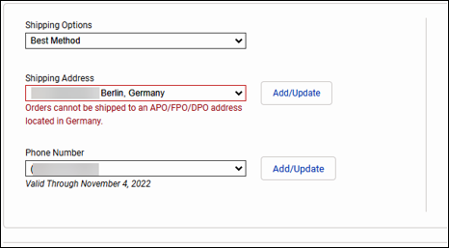

**Canada:**

* The PBM ships prescriptions to Canada. No Controlled Substances or prescriptions requiring Cold Packs are shipped.
* There is a risk that packages could be stopped, delayed, or even not cleared by Canadian customs officials.

**Mexico shipping discontinued 1/1/2013:**

* Mexico requires the recipient of a package containing prescription medications to obtain a permit from the Mexican Health Department prior to the package being shipped. This causes significant delays and timely delivery challenges. The PBM does NOT ship prescriptions to Mexico.

The two-letter abbreviations for the international addresses we will ship to will be displayed in the State field within Compass. Refer to [Address Abbreviations for U.S. Territories and Canada (026065)](https://thesource.cvshealth.com/nuxeo/thesource/#!/view?docid=5c30352b-8c77-4229-9f2f-18599b967424) for descriptions.

For the process to add an international address to a member’s account, refer to the “Scenario Guide” section of [Compass - Add, Edit, Delete Mailing Address (053255)](https://thesource.cvshealth.com/nuxeo/thesource/#!/view?docid=9cfb4422-7129-4bca-b1ea-f1d6fa964906).

Top of the Document

|  |
| --- |
| Exceptions |

All C-II physical hard copy prescriptions should be mailed to the member’s ROCC.

Scan Data shipping system determines the high temperature where the medication is being shipped and if it is above 85 degrees, then it requires someone to sign for the package. This prevents prescriptions that are heat sensitive from sitting in a mailbox for an extended period.

**Note:** Utilizing the Scan Data shipping system allows for carrier adjustments based on the destination of the order and not the pharmacy location.

* If the member questions which geographical areas or regions are affected, warm transfer the call to [Clinical (024833)](https://thesource.cvshealth.com/nuxeo/thesource/#!/view?docid=ff2706a9-6f42-4ccd-87e1-59cb2ce103a8).

Top of the Document

|  |
| --- |
| Related Documents |

[Customer Care Abbreviations, Definitions and Terms (017428)](https://thesource.cvshealth.com/nuxeo/thesource/#!/view?docid=c1f1028b-e42c-4b4f-a4cf-cc0b42c91606)

[Credit for Expedited Shipping Charges - CCR (026438)](https://thesource.cvshealth.com/nuxeo/thesource/#!/view?docid=2492f6f6-b55b-4f56-88f4-c17283a974cd)

[Compass - Order Shipping Turn Around Time (TAT) (062824)](https://thesource.cvshealth.com/nuxeo/thesource/#!/view?docid=31ee69db-e3d5-4717-b336-23ca51f1191e)

**Parent Document** [CALL-0049 Customer Care Internal and External Call Handling](https://policy.corp.cvscaremark.com/pnp/faces/DocRenderer?documentId=CALL-0049)

Top of the Document

Not to Be Reproduced or Disclosed to Others without Prior Written Approval

**ELECTRONIC DATA = OFFICIAL VERSION / PAPER COPY = INFORMATIONAL ONLY**